Midterm 1 CIVILEN 6451 ZEYU WANG

This is the midterm project of using dichromatic reflectance model to find the true scene of the object.

1. First, let’s see our cute puppy:

%% Read the observations with large pixels

A = imread('kobi.png');

figure(1);

imshow(A);



1. Second, we can get the picture via superpixel, here we use 1000 pixels.

%% Use the superpixel to segment the picture

[L,N] = superpixels(A,1000);

observations = zeros(N,3);

outputImage = zeros(size(A),'like',A);

idx = label2idx(L);

numRows = size(A,1);

numCols = size(A,2);

for labelVal = 1:N

redIdx = idx{labelVal};

greenIdx = idx{labelVal}+numRows*numCols;

blueIdx = idx{labelVal}+2*numRows*numCols;

outputImage(redIdx) = mean(A(redIdx));

outputImage(greenIdx) = mean(A(greenIdx));

outputImage(blueIdx) = mean(A(blueIdx));

observations(labelVal,:) = [mean(A(redIdx)) mean(A(greenIdx)) mean(A(blueIdx))];

end

figure(2);

imshow(outputImage,'InitialMagnification',67);

Now the picture looks like this:



1. Now, it is the time to find the $C_{d}$ via Gauss-Seidel iterations.

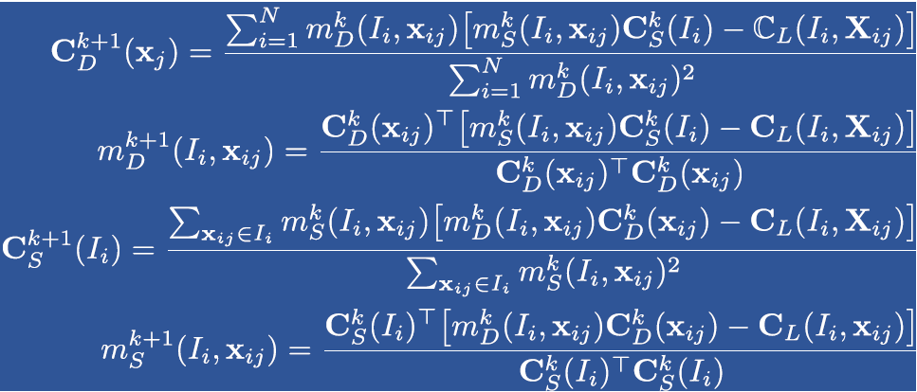

In Matlab the implementation looks like this, here we use 1000 iterations:

%% Use the Gauss-Seidel iterations to minimize the cost function

% Initialize the parameters here

C_l = observations;

C_d = 100*ones(N,3);

M_d = ones(1,N);

C_s = 100*ones(1,3);

M_s = ones(1,N);

for p = 1:1000

for j = 1:N

M_d(j) = C_d(j,:)*(C_l(j,:) - M_s(j)*C_s)'/(C_d(j,:)*C_d(j,:)');

end

for j = 1:N

M_s(j) = C_s*(C_l(j,:)-M_d(j)*C_d(j,:))'/(C_s*C_s');

end

C_s(1) = sum(M_s.*(C_l(:,1)'-M_d.*C_d(:,1)'))/(sum(M_s.^2));

C_s(2) = sum(M_s.*(C_l(:,2)'-M_d.*C_d(:,2)'))/(sum(M_s.^2));

C_s(3) = sum(M_s.*(C_l(:,3)'-M_d.*C_d(:,3)'))/(sum(M_s.^2));

for j = 1:N

C_d(j,1) = M_d(j)*(C_l(j,1) - M_s(j)*C_s(1))/M_d(j)^2;

C_d(j,2) = M_d(j)*(C_l(j,2) - M_s(j)*C_s(2))/M_d(j)^2;

C_d(j,3) = M_d(j)*(C_l(j,3) - M_s(j)*C_s(3))/M_d(j)^2;

end

end

1. Now, the $C_{d}$ is available and the true scene can be obtained by:

%% Output the true color of objects

TrueImage = zeros(size(A),'like',A);

for labelVal = 1:N

redIdx = idx{labelVal};

greenIdx = idx{labelVal}+numRows*numCols;

blueIdx = idx{labelVal}+2*numRows*numCols;

TrueImage(redIdx) = C_d(labelVal,1);

TrueImage(greenIdx) = C_d(labelVal,2);

TrueImage(blueIdx) = C_d(labelVal,3);

end

figure(3);

imshow(TrueImage,'InitialMagnification',67);

Finall, we can see the true scene:



Em….This picture seems weird but the general shape is reasonable. The illumination $C_{s}$ is also available which is:

116.98 97.15 85.86

For Red Green Blue.